Standard Operating Procedure
Step-by-Step Workflow Documentation

Step 1: Step 1
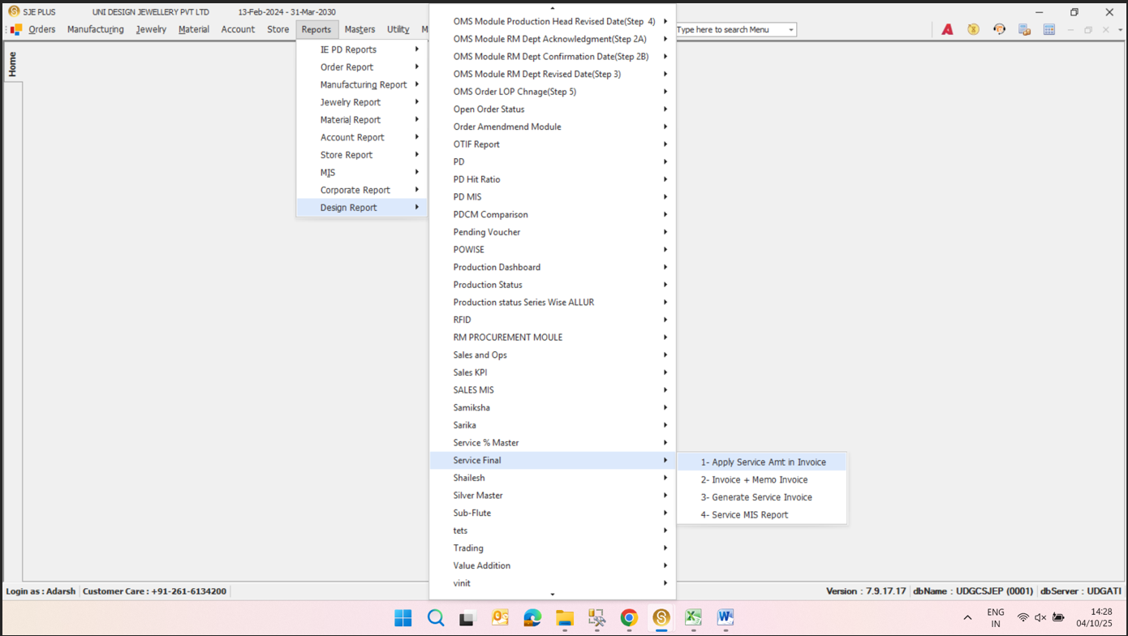
1- Apply Service Amt in Invoice
Key objects & actions:
- 1- Apply Service Amt in Invoice —
- 2- Invoice + Memo Invoice —
- 3- Generate Service Invoice —
- 4- Service MIS Report —

Step 2: Step 2
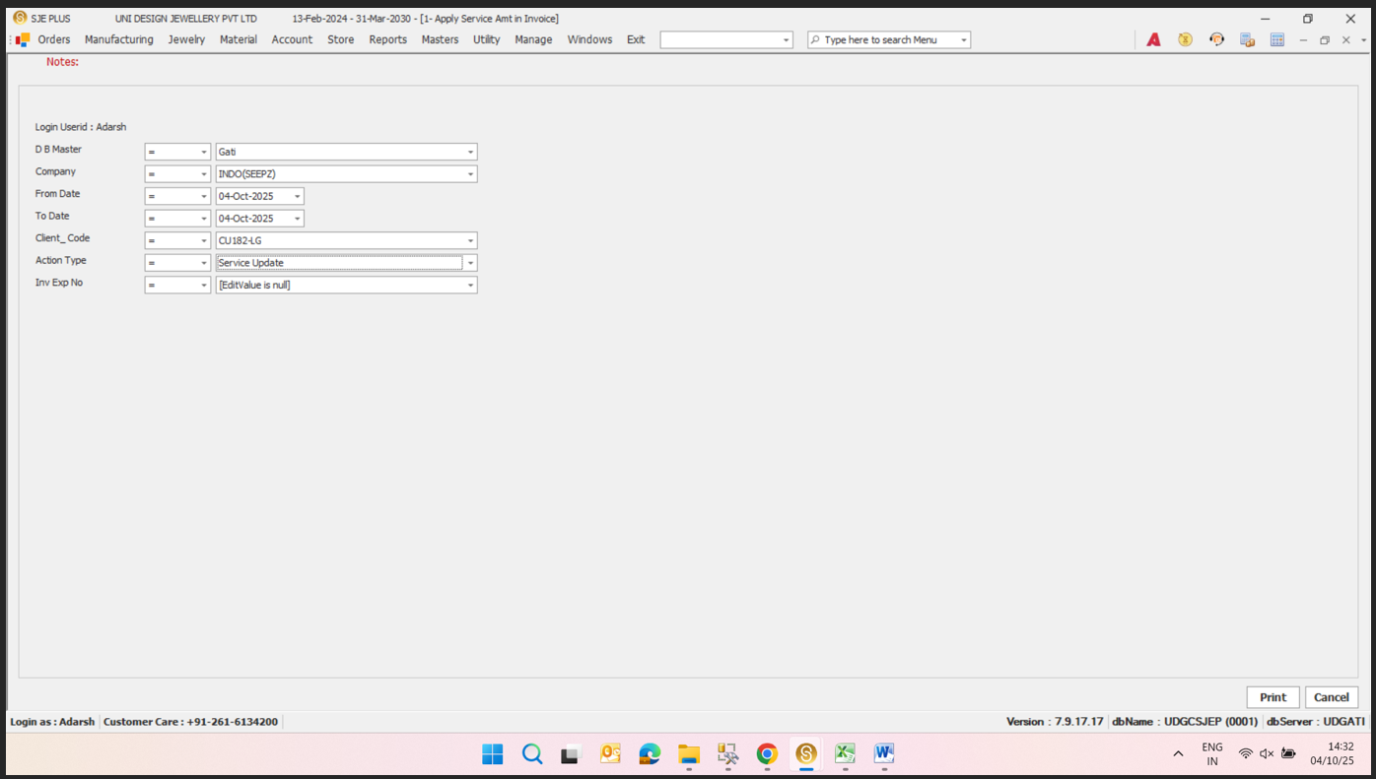
**Login User
Key objects & actions:
- **Login User — ** Adarsh
- **DB Master — ** Adarsh
- **Company — ** INDO(SEEPZ)
- **From Date — ** 04-Oct-2025
- **To Date — ** 04-Oct-2025
- **Client Code — ** CU1824G
- **Action Type — ** Service Update

Step 3: Step 3
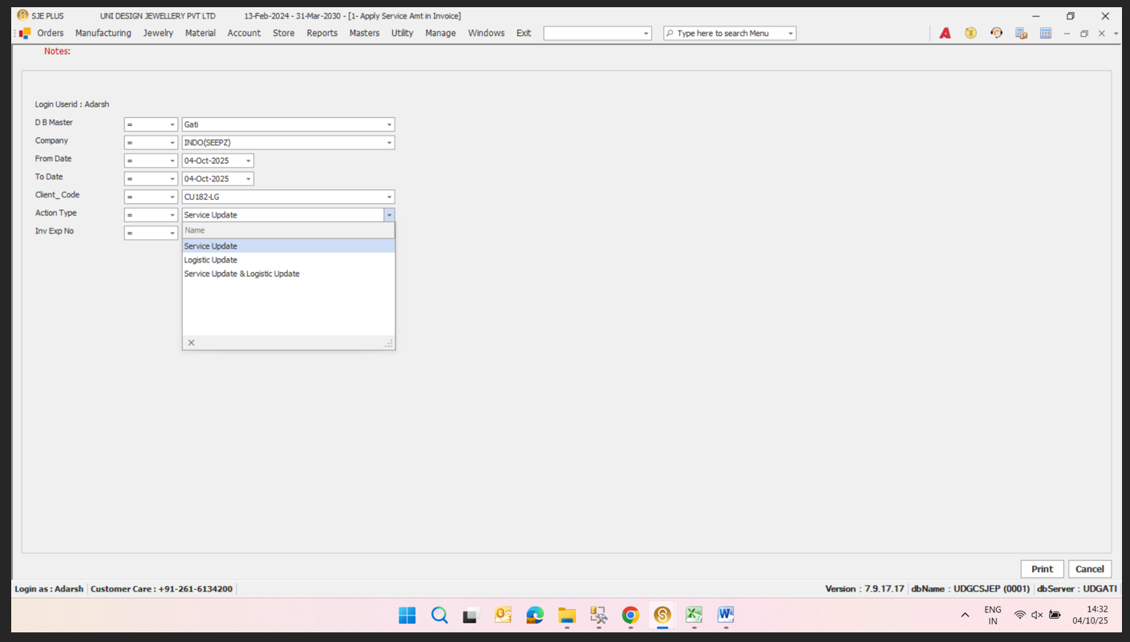
Service Update
Key objects & actions:
- Service Update —
- Logistic Update —
- Service Update & Logistic Update —

